Draw and explain the Java thread life-cycle states, then map each state to a real symptom an engineer would observe in a thread dump of a hung production server.

Java Thread Life-Cycle States
1. Aim
To study and demonstrate the life-cycle states of a Java thread and understand how each state appears in a thread dump of a hung production server.

2. Algorithm
- Start the program.
- Create a new thread using the Thread class.
- Observe the thread in the NEW state before calling start().
- Start the thread using start().
- The thread enters the RUNNABLE state.
- Make the thread enter TIMED_WAITING using sleep().
- Create another thread that enters the WAITING state using wait().
- Demonstrate BLOCKED by making two threads compete for the same synchronized lock.
- After the run() method completes, the thread enters the TERMINATED state.
- Map these states to symptoms that an engineer could identify from a production thread dump.

3. Pseudocode
BEGIN

Create Thread T1
Display T1 state
→ NEW

Start T1
→ RUNNABLE

Inside T1:
Sleep for some time
→ TIMED_WAITING

Create Thread T2
T2 waits using wait()
→ WAITING

Create two threads using synchronized method
One thread obtains the lock
Other thread waits for the lock
→ BLOCKED

Allow threads to complete
→ TERMINATED

END

4. Java Program
class ThreadLifeCycle {

// Shared lock for demonstrating BLOCKED state
static final Object lock = new Object();

// Thread for TIMED_WAITING
static class SleepThread extends Thread {
public void run() {
try {
System.out.println("SleepThread: RUNNABLE");

Thread.sleep(3000);

System.out.println("SleepThread: Woke up");
} catch (InterruptedException e) {
System.out.println("Thread interrupted");
}
}
}

// Thread for WAITING
static class WaitingThread extends Thread {

public void run() {
synchronized (lock) {
try {
System.out.println("WaitingThread: WAITING");
lock.wait();
} catch (InterruptedException e) {
System.out.println("Thread interrupted");
}
}
}
}

// Thread for BLOCKED state
static class BlockedThread extends Thread {

public void run() {
synchronized (lock) {
System.out.println(
"BlockedThread: Lock acquired"
);
}
}
}

public static void main(String[] args)
throws InterruptedException {

// -----------------------------
// NEW STATE
// -----------------------------
SleepThread t1 = new SleepThread();

System.out.println(
"State before start: " + t1.getState()
);

// -----------------------------
// RUNNABLE STATE
// -----------------------------
t1.start();

Thread.sleep(100);

System.out.println(
"State after start: " + t1.getState()
);

// -----------------------------
// WAITING STATE
// -----------------------------
WaitingThread t2 = new WaitingThread();

t2.start();

Thread.sleep(100);

System.out.println(
"WaitingThread state: " + t2.getState()
);

// -----------------------------
// BLOCKED STATE
// -----------------------------
synchronized (lock) {

BlockedThread t3 = new BlockedThread();

t3.start();

Thread.sleep(100);

System.out.println(
"BlockedThread state: " + t3.getState()
);
}

// Wake the waiting thread
synchronized (lock) {
lock.notify();
}

// Wait for threads to finish
t1.join();
t2.join();

// -----------------------------
// TERMINATED STATE
// -----------------------------
System.out.println(
"SleepThread final state: " + t1.getState()
);

System.out.println(
"WaitingThread final state: " + t2.getState()
);

System.out.println("Program completed.");
}
}
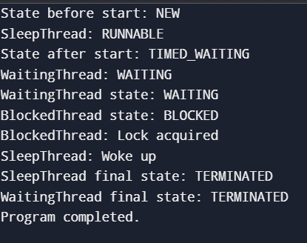
OUTPUT

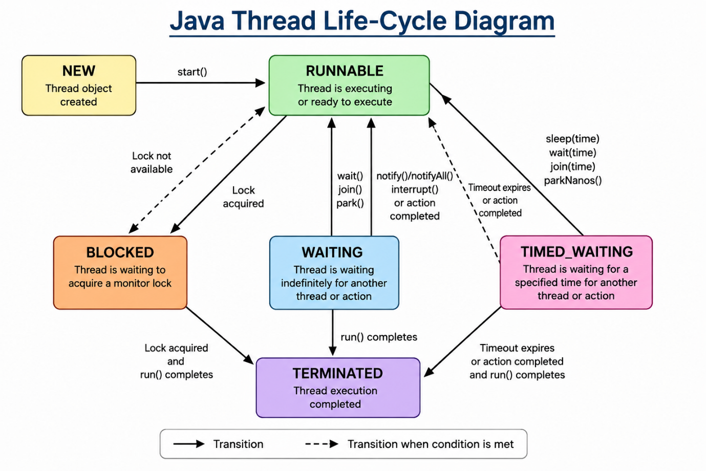
5. Thread Life-Cycle Diagram

6. Thread Dump Mapping
Java State | What it means | Real production symptom
NEW | Thread created but not started | Worker/task never begins
RUNNABLE | Thread is running or ready to run | High CPU usage or CPU-intensive loop
BLOCKED | Waiting to acquire a monitor lock | Many requests stuck waiting for the same lock
WAITING | Waiting indefinitely for another thread/action | Worker threads remain stuck waiting
TIMED_WAITING | Waiting for a specified period | Threads sleeping, waiting for timeout, or delayed
TERMINATED | Thread has finished | Worker unexpectedly stops processing tasks

7. Example Thread-Dump Analysis
A production server might show:
"Worker-1" RUNNABLE

"Worker-2" BLOCKED
waiting to lock <0x00000001>

"Worker-3" WAITING

"Worker-4" TIMED_WAITING
at java.lang.Thread.sleep()

"Worker-5" TERMINATED
Engineer's interpretation
RUNNABLE
→ Check for high CPU usage or infinite loops.
BLOCKED
→ Check which thread owns the lock.
WAITING
→ Check what the thread is waiting for and whether the required thread is stuck.
TIMED_WAITING
→ Check whether the delay is expected or excessive.
TERMINATED
→ Check whether the thread ended normally or because of an exception.

8. Result
Thus, the Java Thread Life-Cycle was studied and the six thread states — NEW, RUNNABLE, BLOCKED, WAITING, TIMED_WAITING, and TERMINATED — were identified. Their corresponding symptoms in a production thread dump were also analyzed to understand how engineers can diagnose a hung server.

